Langsmith Tracing

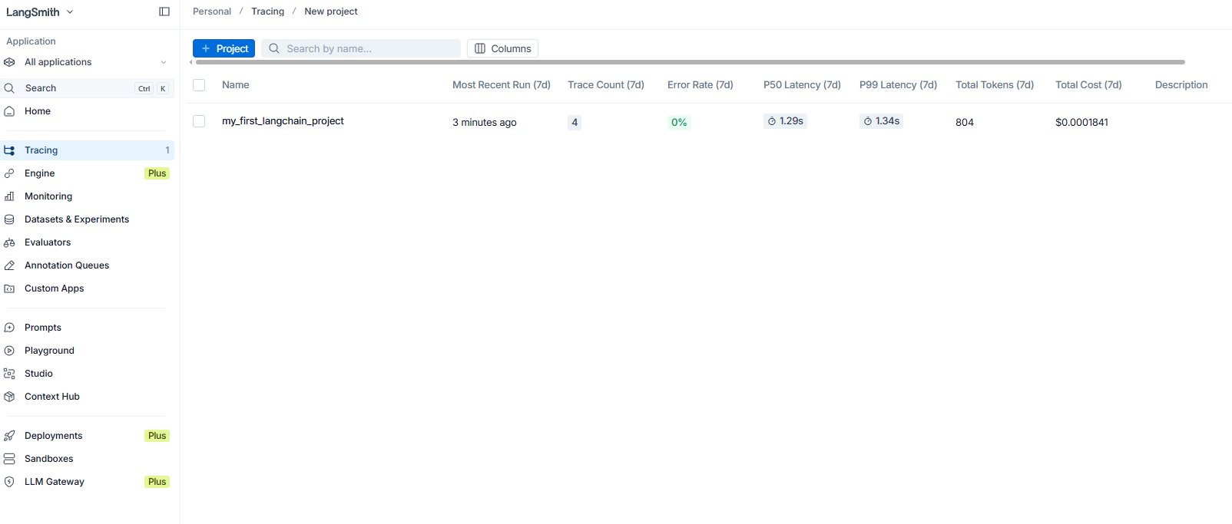

Detailed Tracking in Langsmit

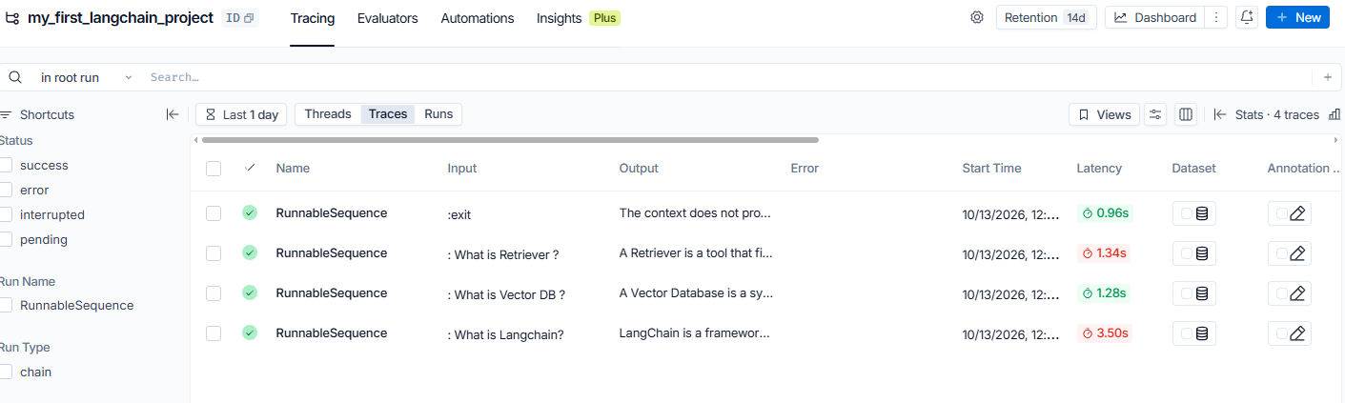

Open AI – Usage
